* Testing
* Java
* Selenium and Frameworks
* Maven, Jenkins, GIT ,DevOps, Agile methodology
* Cucumber and API

**Testing**

1. What all types of testing have you performed? (sanity, smoke, functional, regression)
2. Diff between Smoke and Sanity testing? (early stage vs later stage)
3. Diff between Functional and non-functional testing?
4. Diff between White box and black box testing?
5. Diff between TDD and BDD?

**Java**

1. Which java version you are using for automation (1.8)
2. What are different data types in java? (byte, short, int, char, long, float, double, boolean)
3. Is String a dataype or class?
4. Are Strings mutable or immutable? Why are they immutable in java? 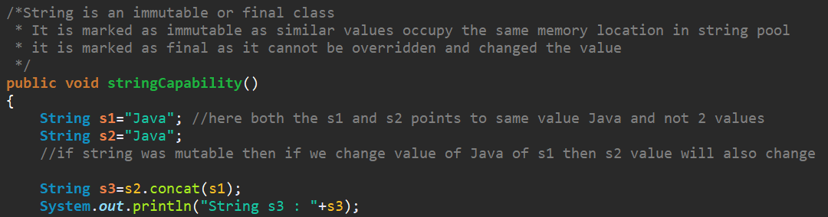
5. What is disadvantage of one dim array? 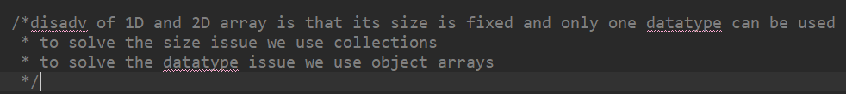
6. What is a class and object?
7. Different variables in Java? ( Local, Instance, Static)
8. What are the different access modifiers in Java?

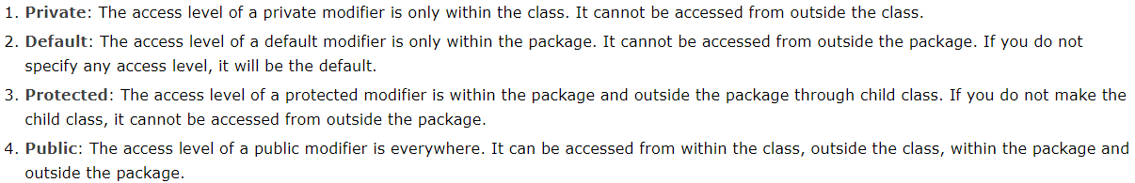

1. Static vs non static? (memory location)
2. How are static methods accessed from another method?
3. Integer to String (string.valueof) or String to Integer (Integer.Parseint)
4. What is polymorphism?
5. Diff between Method Overloading and Method Overriding? Super Keyword
6. Could you give an example of static and dynamic polymorphism in your selenium project?
7. Constructors and This keyword. Why are constructors used?
8. Could you explain a real time example of the use of Constructor in your project?
9. What is inheritance? Multiple inheritance is not supported in Java and its alternative?
10. Superclass name is Box1 and Subclass name is Box2. What is the difference between

Box1 obj=new Box1();

Box2 obj=new Box2();

Box1 obj=new Box2();

1. How is abstraction implemented in your project?
2. Difference between an Interface and Abstract class.
3. Could you explain a real time example of the use of Abstraction in your selenium project?
4. What is difference between static and dynamic polymorphism?
5. Final vs finally vs finalize?
6. Throw vs Throws vs Throwable? (Throwable –superclass of error and exception)
7. Try, catch block
8. What are the different types of exceptions that you have encountered in your project?
9. What is stale element reference exception?
10. Define multithreading in Java.
11. What is Collections in Java? 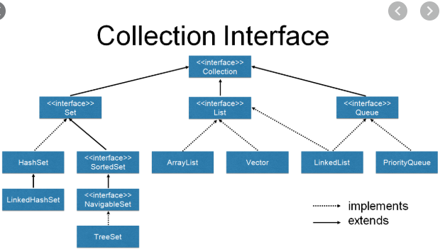
12. How can we traverse through a collection? (iterator and for each loop)
13. Is Map interface a part of collections ?
14. What is the difference between Hashtable and Hashmap in Java? (synchronized vs nonsynchronized)
15. If we have to store the elements in a sorted manner which Collection is used?
16. How can we traverse a map such as hashmap if Map interface is not a part of collections?
17. Memory allocation in Java 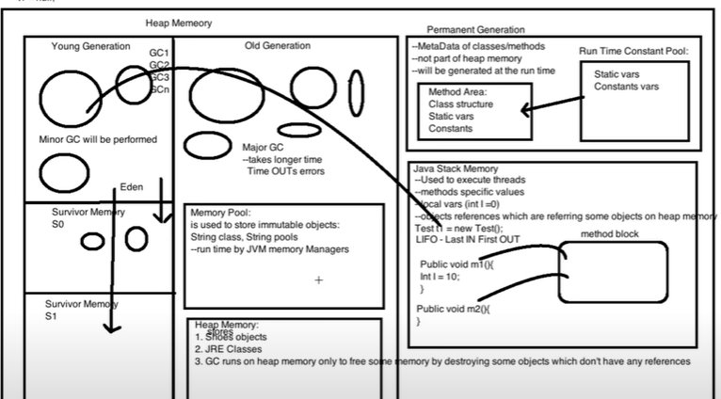

**Selenium**

1. Advantages of Selenium over other automation tools? (Cross platform, Portable)
2. Disadv of selenium?
3. What are challenges that you have faced in automation?
4. What are the steps that you perform once you find that one of the automation test cases has failed ? (Debugging)
5. What are the steps that are performed in selenium from launching a browser, logging into application and then close the browser?
6. What is WebDriver manager API ?
7. What does WebDriver driver=new ChromeDriver() mean and why not WebDriver driver=new WebDriver()?
8. Which are the browser API drivers that can be used with Selenium? Could you please list some of the drivers which run in headless mode?
9. Is there any way to run Chrome and Firefox browser drivers in headless mode? (chromeoptions and firefoxoptions)
10. Could you list the locators in selenium? (id ,name, class , linktext, partiallinktext, cssselector, xpath, tagname), what is the hierarchy that you prefer to use them in your code?
11. Difference between absolute and relative xpath?
12. Can you name some of the xpath axes methods? (parent, child, ancestor, descendant etc.)
13. What are the different Synchronization methods in Selenium? (Thread. Sleep, Pageloadtimeout, implicit, explicit, fluent).
14. Could you explain the in detail about implicit, explicit and fluent waits and their syntax?
15. Can we combine and use implicit and explicit waits? Which wait among these apply at the browser API level and which applies at the code level?
16. Difference between findElement and findElements?
17. How to switch between frames in Selenium?
18. How to handle alerts in the application?
19. How to switch between windows in Selenium? (Getwindowhandles)
20. How do you handle a non-web based popup such as a windows based popup in Selenium?
21. How does getWindowhandles work?
22. How to navigate between pages in Selenium? How to directly pass the username and password in url?
23. How to take screenshots in Selenium?
24. How to handle dropdowns in Selenium? (Select). What are the methods in Select class?
25. How to handle dropdown in selenium which are not having Select tag?
26. How to handle mouse actions in selenium? What all methods does actions class provide? Why we use .build().perform() with Actions class methods?
27. What is the super interface of WebDriver? (SearchContext)
28. Could you explain the WebDriver architecture hierarchy?
29. How to automate dynamic DOM elements when usual selenium commands are not working? (JSE)
30. What are the functionalities that can be performed using JSE?
31. How to handle a dynamic Webtable in selenium?
32. How to handle Calendar in Selenium?
33. How to find broken links in a page?
34. Difference between Hard Assert and Soft Assert? When are they used?
35. What is TestNG framework? What are the advantages of using TestNG framework? (annotations, grouping, parallel testing)
36. What are the different annotations in testng?
37. What is the hierarchy in which the annotations are executed?
38. How can we group the test cases in Testng?
39. How can we decide the order in which the testcases needs to be run? (priority)
40. How can we decide that one testcase must run only after a specific testcase? (dependency - @Test(dependsOnMethods = { "SignIn", "OpenBrowser" }))
41. How can we decide that one testcase must run only after a specific set of testcases are executed? (dependency - @Test(dependsOnGroups = { "SignIn" }))
42. Which are the reports generated by default by Testng? (index.html)
43. What are Listeners in testng?
44. What are extent Reports? how can we configure them along with testNG?
45. How can we generate log files in Selenium? (Log4j)
46. Parameters in testng? 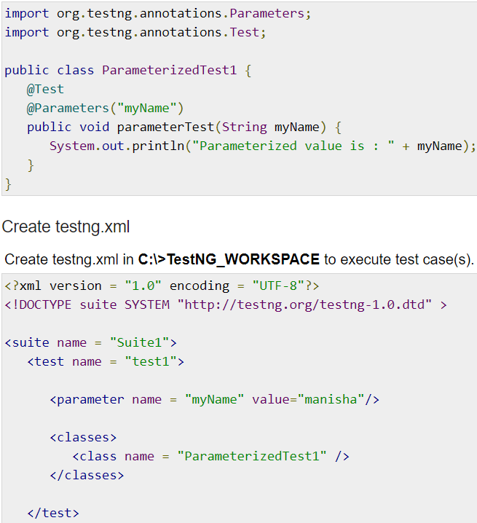
47. How is datadriven testing implemented in testng using dataProvider functionality?
48. What is the return type of dataprovider?
49. How Apache POI can be used to achieve data driven testing in Selenium. Could you explain the steps to access a cell data from a cell in either XLS or XLSX workbook?
50. How is parallel testing accomplished using Testng? 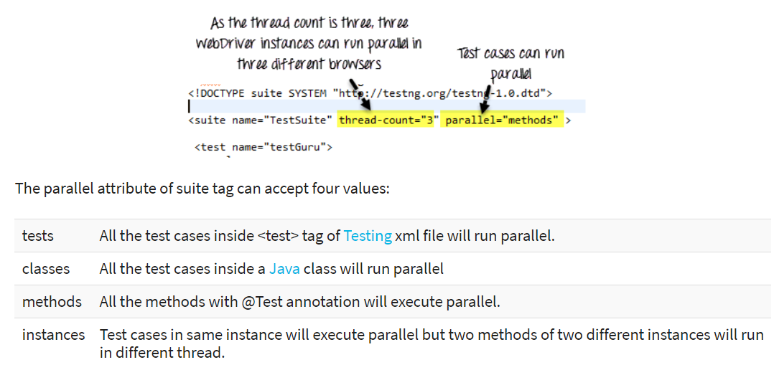
51. What does the thread-count value mean?
52. How many thread-count value is needed if we have to execute 10 testcases parallely?
53. What is Selenium Grid? What is hub and node in grid? What is DesiredCapabilities class?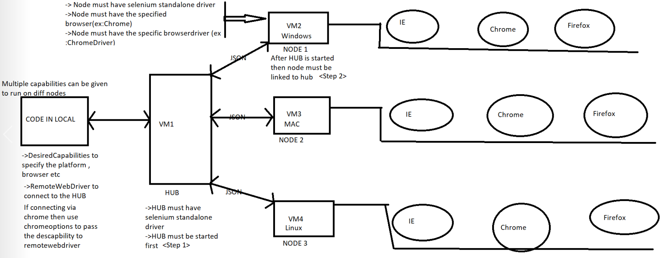
54. How can we ignore a test in testng? (@Test(enabled=false))
55. How can we run a single test case 10 times in Testng? (invocationcount=10)
56. How can we rerun failed test cases in testng? (IRetryAnalyzer and IAnnotationTransformer)
57. How can we take the screenshot of failed test cases in TestNG? (iTestListener)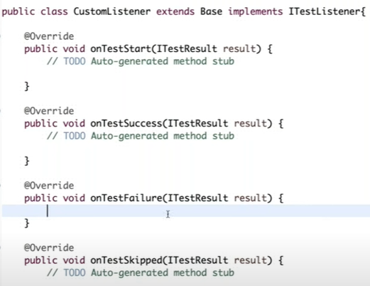
58. What does verbose signify in testng.xml file? 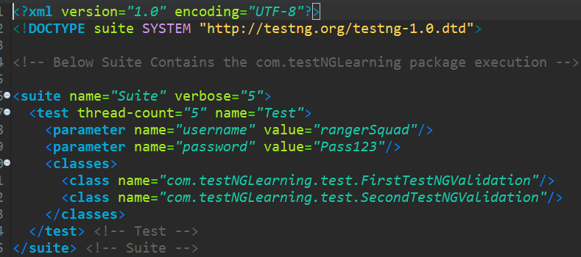
59. How to verify that a table is empty or not in Selenium? (find Elements).
60. How to find the links which are not loading in a page ? (HttpURLConnection)
61. What all frameworks have you worked in your projects? (Linear, Data driven, Hybrid, POM)
62. Have you created your own frameworks from scratch or have you worked on already existing frameworks?
63. Could you explain the last framework that you have worked in?
64. What is Page object model (POM) framework?
65. What is page Factory? By locator in selenium? 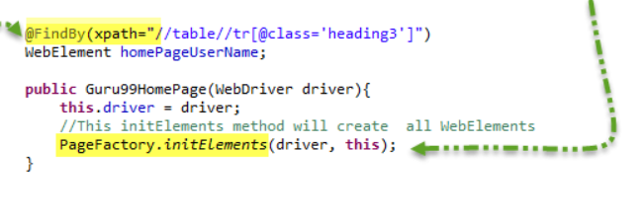
66. Have you used config.properties file in your framework? Could you describe under which Collection interface does properties come under?

* **Maven, Jenkins, GIT ,DevOps, Agile**

1. What is DevOps?
2. What is Maven and what is the advantage of using Maven? (build automation tool)
3. What is pom.xml file? What are maven dependencies?
4. How can we check the version of maven installed in our system? (mvn –version)
5. What is maven lifecycle? What are the main maven plugins? (compiler, surefire, resource).
6. What is Jenkins? (continuous integration tool)
7. What is Jenkins pipeline or blue ocean?
8. How can we schedule a job to run at a specific time?
9. What is cron-compliant format in Jenkins? 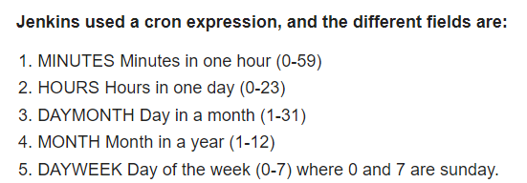
10. What is agile methodology ?
11. What are the duties of Scrum master and product manager?
12. What is sprint retrospective?
13. What is the defect lifecycle in JIRA?
14. What is a spike?

*GIT questions from the GIT doc.

* **Cucumber and API**

1. What is Cucumber? How does Cucumber implement BDD concept? (feature files, step definitions, runner class)
2. What are the Gherkin keywords?
3. What are cucumber options in runner class? 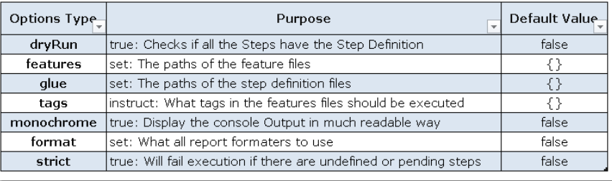
4. How is datadriven testing accomplished in Cucumber? (Examples, Datatable, Map)
5. What are tags and hooks in Cucumber?
6. What is API?
7. What are the API methods? (GET, POST, PUT, PATCH and DELETE)